O K L A H O M A S T A T E S E N A T E
JOINT

COMMITTEE REPORT

May 17, 2019

JOINT COMMITTEE ON APPROPRIATIONS AND BUDGET

SB 1069

By: Thompson and Rader of the Senate and Wallace and Hilbert of the House

Title: Public finance; specifying certain duty. Emergency.

Recommendation: DO PASS AS AMENDED

Aye: Bice, Daniels, Dugger, Hall, Jech, Kidd, Montgomery, Pemberton, Pugh, Rosino, Scott, Simpson, Stanislawski, Rader, Thompson

Nay: Brooks, Ikley-Freeman

Constitutional Privilege:

Senator Roger Thompson, Chair

Committee Substitute, motion by Senator THOMPSON - Adopted (Request No: 2325)

SB1069,1220,F,JOINT
OKLAHOMA HOUSE OF REPRESENTATIVES
COMMITTEE REPORT

JOINT COMMITTEE ON APPROPRIATIONS AND BUDGET COMMITTEE

SB1069

By: | Wallace et al of the House  Thompson et al of the Senate
Title: | Public finance; specifying certain duty. Emergency.
Coauthored By:
Recommendation: | DO PASS AS AMENDED BY CS

Amendments:

1. Committee Substitute Attached

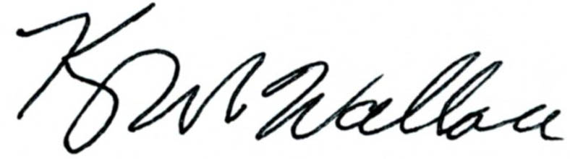
______________________________________ Chr.
Representative Kevin Wallace

YEAS: 24

Bennett, Echols, Fetgatter, Ford, Goodwin, Hilbert, Lawson, Lepak, Martinez, McEntire, Meredith, Munson, Nichols, Ortega, Pfeiffer, Roberts (D), Sanders, Taylor, Virgin, Walke, Wallace, West (J), West (K), Worthen

NAYS: 0

CONSTITUTIONAL PRIVILEGE: 0
STATE OF OKLAHOMA

1st Session of the 57th Legislature (2019)

COMMITTEE SUBSTITUTE
FOR
SENATE BILL NO. 1069 By: Thompson and Rader of the Senate

and

Wallace and Hilbert of the House

COMMITTEE SUBSTITUTE

An Act relating to the Revenue Stabilization Fund; making appropriations to the Revenue Stabilization Fund; stating purpose; and providing an effective date.

BE IT ENACTED BY THE PEOPLE OF THE STATE OF OKLAHOMA:
SECTION 1. There is hereby appropriated to the Revenue Stabilization Fund created pursuant to Section 34.102 of Title 62 of the Oklahoma Statutes from any monies not otherwise appropriated from the General Revenue Fund of the State Treasury for the fiscal year ending June 30, 2020, the sum of One Hundred Eighty-six Million Eighty-four Thousand Seven Hundred Eighty-two Dollars ($186,084,782.00), to be utilized as provided by law.
SECTION 2. There is hereby appropriated to the Revenue Stabilization Fund created pursuant to Section 34.102 of Title 62 of the Oklahoma Statutes from any monies not otherwise appropriated from the Alcoholic Beverage Control Fund, the sum of Thirteen Million Nine Hundred Fifteen Thousand Two Hundred Eighteen Dollars ($13,915,218.00), to be utilized as provided by law.
SECTION 3. This act shall become effective September 1, 2019.

57-1-2325 AS 7/30/2026 10:10:03 AM

