O K L A H O M A S T A T E S E N A T E
JOINT

COMMITTEE REPORT

May 16, 2019

JOINT COMMITTEE ON APPROPRIATIONS AND BUDGET

SB 1066

By: Thompson and Rader of the Senate and Wallace and Hilbert of the House

Title: Appropriation; making an appropriation to the Office of Juvenile Affairs. Emergency.

Recommendation: DO PASS AS AMENDED

Aye: Bice, Brooks, Daniels, Dossett, Dugger, Floyd, Hall, Ikley-Freeman, Jech, Kidd, Matthews, Montgomery, Pemberton, Pugh, Rosino, Scott, Shaw, Simpson, Stanislawski, Rader, Thompson

Nay:

Constitutional Privilege:

Senator Roger Thompson, Chair

Committee Substitute, motion by Senator RADER - Adopted (Request No: 2310)

SB1066,1220,F,JOINT
OKLAHOMA HOUSE OF REPRESENTATIVES
COMMITTEE REPORT

JOINT COMMITTEE ON APPROPRIATIONS AND BUDGET COMMITTEE

SB1066

By: | Wallace et al of the House  Thompson et al of the Senate
Title: | Appropriation; making an appropriation to the Office of Juvenile Affairs. Emergency.
Coauthored By:
Recommendation: | DO PASS AS AMENDED BY CS

Amendments:

1. Committee Substitute Attached

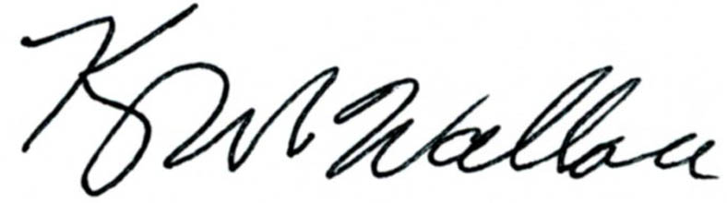
______________________________________ Chr.
Representative Kevin Wallace

YEAS: 25

Bennett, Echols, Fetgatter, Ford, Hilbert, Kannady, Lawson, Lepak, Martinez, McEntire, Meredith, Munson, Nichols, O'Donnell, Ortega, Osburn, Pfeiffer, Roberts (D), Sanders, Taylor, Virgin, Walke, Wallace, West (J), Worthen

NAYS: 1

West (K)

CONSTITUTIONAL PRIVILEGE: 0
STATE OF OKLAHOMA

1st Session of the 57th Legislature (2019)

COMMITTEE SUBSTITUTE
FOR
SENATE BILL NO. 1066 By: Thompson and Rader of the Senate

and

Wallace and Hilbert of the House

COMMITTEE SUBSTITUTE

An Act relating to appropriations; making an appropriation to the Oklahoma Indigent Defense System; stating purpose; providing lapse dates; requiring and prohibiting certain budget procedures; and providing a contingent effective date.

BE IT ENACTED BY THE PEOPLE OF THE STATE OF OKLAHOMA:
SECTION 1. There is hereby appropriated to the Oklahoma Indigent Defense System from any monies not otherwise appropriated from the General Revenue Fund of the State Treasury for the fiscal year ending June 30, 2020, the sum of Two Million Dollars ($2,000,000.00) or so much thereof as may be necessary to implement the provisions of Enrolled Senate Bill No. 252 of the 1st Session of the 57th Oklahoma Legislature.
SECTION 2. Appropriations made by this act, not including appropriations made for capital outlay purposes, may be budgeted for the fiscal year ending June 30, 2020 (hereafter FY-20), or may be budgeted for the fiscal year ending June 30, 2021 (hereafter FY-21). Funds budgeted for FY-20 may be encumbered only through June 30, 2020, and must be expended by November 15, 2020. Any funds remaining after November 15, 2020, and not budgeted for FY-21, shall lapse to the credit of the proper fund for the then current fiscal year. Funds budgeted for FY-21 may be encumbered only through June 30, 2021. Any funds remaining after November 15, 2021, shall lapse to the credit of the proper fund for the then current fiscal year. These appropriations may not be budgeted in both fiscal years simultaneously. Funds budgeted in FY-20 and not required to pay obligations for that fiscal year, may be budgeted for FY-21, after the agency to which the funds have been appropriated has prepared and submitted a budget work program revision removing these funds from the FY-20 budget work program and after such revision has been approved by the Office of Management and Enterprise Services.
SECTION 3. The provisions of this act shall not become effective as law unless Enrolled Senate Bill No. 252 of the 1st Session of the 57th Oklahoma Legislature becomes effective as law.

57-1-2310 RC 7/30/2026 6:46:47 AM

