O K L A H O M A S T A T E S E N A T E

JOINT COMMITTEE REPORT

May 17, 2019

JOINT COMMITTEE ON APPROPRIATIONS AND BUDGET

SB 1064

By: Thompson and Rader of the Senate and Wallace and Hilbert of the House

Title: Appropriation; making an appropriation to the Oklahoma Department of Commerce. Emergency.

Recommendation: DO PASS AS AMENDED

Aye: Bice, Brooks, Daniels, Dugger, Hall, Ikley-Freeman, Jech, Kidd, Montgomery, Pemberton, Pugh, Rosino, Scott, Simpson, Stanislawski, Rader, Thompson

Nay:

Constitutional Privilege:

Senator Roger Thompson, Chair

Committee Substitute, motion by Senator THOMPSON - Adopted (Request No: 2319)

SB1064,1220,F,JOINT
OKLAHOMA HOUSE OF REPRESENTATIVES
COMMITTEE REPORT

JOINT COMMITTEE ON APPROPRIATIONS AND BUDGET COMMITTEE

SB1064

By: | Wallace et al of the House  Thompson et al of the Senate
Title: | Appropriation; making an appropriation to the Oklahoma Department of Commerce. Emergency.
Coauthored By:
Recommendation: | DO PASS AS AMENDED BY CS

Amendments:

1. Committee Substitute Attached

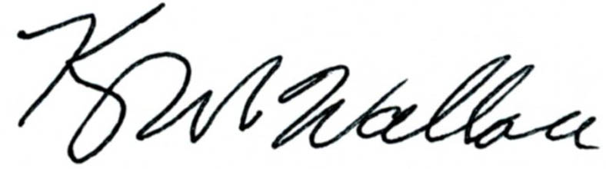
______________________________________ Chr.
Representative Kevin Wallace

YEAS: 24

Bennett, Echols, Fetgatter, Ford, Goodwin, Hilbert, Lawson, Lepak, Martinez, McEntire, Meredith, Munson, Nichols, Ortega, Pfeiffer, Roberts (D), Sanders, Taylor, Virgin, Walke, Wallace, West (J), West (K), Worthen

NAYS: 0

CONSTITUTIONAL PRIVILEGE: 0
STATE OF OKLAHOMA

1st Session of the 57th Legislature (2019)

COMMITTEE SUBSTITUTE
FOR
SENATE BILL NO. 1064 By: Thompson and Rader of the Senate

and

Wallace and Hilbert of the House

COMMITTEE SUBSTITUTE

An Act relating to the Oklahoma Historical Society; requiring that portions of certain appropriated funds be used for certain purposes; providing an effective date; and declaring an emergency.

BE IT ENACTED BY THE PEOPLE OF THE STATE OF OKLAHOMA:
SECTION 1. From the funds appropriated to the Oklahoma Historical Society in Enrolled House Bill No. 2765 of the 1st Session of the 57th Oklahoma Legislature, not less than Seventy Thousand Dollars ($70,000.00) shall be used to provide for the Will Rogers Memorial Museum. These funds shall be used to provide additional funding for the Will Rogers Memorial Museum and shall be used to supplement rather than replace existing resources.
SECTION 2. From the funds appropriated to the Oklahoma Historical Society in Enrolled House Bill No. 2765 of the 1st Session of the 57th Oklahoma Legislature, the sum of One Million Five Hundred Thousand Dollars ($1,500,000.00) shall be transferred to the 1921 Tulsa Race Riot Centennial Memorial Revolving Fund created in Section 8207 of Title 74 of the Oklahoma Statutes.
SECTION 3. From the funds appropriated to the Oklahoma Historical Society in Enrolled House Bill No. 2765 of the 1st Session of the 57th Oklahoma Legislature, not less than Six Hundred Thousand Dollars ($600,000.00) shall be used to provide for roof and structure rehabilitation of the Oklahoma History Center.
SECTION 4. From the funds appropriated to the Oklahoma Historical Society in Enrolled House Bill No. 2765 of the 1st Session of the 57th Oklahoma Legislature, not less than Two Hundred Fifty Thousand Dollars ($250,000.00) shall be used to provide for the Stafford Air and Space Museum. These funds shall be used to provide additional funding for the Stafford Air and Space Museum and shall be used to supplement rather than replace existing resources.
SECTION 5. This act shall become effective July 1, 2019.
SECTION 6. It being immediately necessary for the preservation of the public peace, health or safety, an emergency is hereby declared to exist, by reason whereof this act shall take effect and be in full force from and after its passage and approval.

57-1-2319 QD 7/30/2026 1:54:12 PM

