O K L A H O M A S T A T E S E N A T E
JOINT

COMMITTEE REPORT

May 17, 2019

JOINT COMMITTEE ON APPROPRIATIONS AND BUDGET

SB 1060

By: Thompson and Rader of the Senate and Wallace and Hilbert of the House

Title: Appropriation; making an appropriation to the State Board of Career and Technology Education. Emergency

Recommendation: DO PASS AS AMENDED

Aye: Bice, Brooks, Daniels, Dugger, Hall, Ikley-Freeman, Jech, Kidd, Montgomery, Pemberton, Pugh, Rosino, Scott, Simpson, Stanislawski, Rader, Thompson

Nay:

Constitutional Privilege:

Senator Roger Thompson, Chair

Committee Substitute, motion by Senator THOMPSON - Adopted (Request No: 2298)

SB1060,1220,F,JOINT
OKLAHOMA HOUSE OF REPRESENTATIVES
COMMITTEE REPORT

JOINT COMMITTEE ON APPROPRIATIONS AND BUDGET COMMITTEE

SB1060

By: | Wallace et al of the House  Thompson et al of the Senate
Title: | Appropriation; making an appropriation to the State Board of Career and Technology Education. Emergency
Coauthored By:
Recommendation: | DO PASS AS AMENDED BY CS

Amendments:

1. Committee Substitute Attached

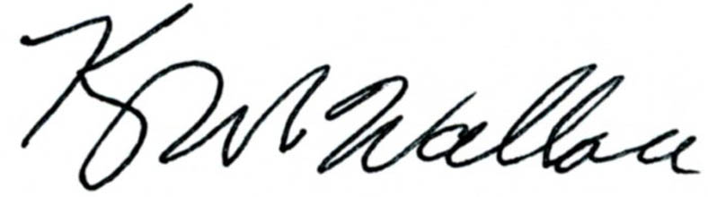
______________________________________ Chr.
Representative Kevin Wallace

YEAS: 24

Bennett, Echols, Fetgatter, Ford, Goodwin, Hilbert, Lawson, Lepak, Martinez, McEntire, Meredith, Munson, Nichols, Ortega, Pfeiffer, Roberts (D), Sanders, Taylor, Virgin, Walke, Wallace, West (J), West (K), Worthen

NAYS: 0

CONSTITUTIONAL PRIVILEGE: 0
STATE OF OKLAHOMA

1st Session of the 57th Legislature (2019)

COMMITTEE SUBSTITUTE
FOR
SENATE BILL NO. 1060 By: Thompson and Rader of the Senate

and

Wallace and Hilbert of the House

COMMITTEE SUBSTITUTE

An Act relating to the Oklahoma Department of Veterans Affairs; requiring budgeting in certain categories and amounts; providing budgetary limitations; requiring and prohibiting certain budget procedures; providing lapse dates; providing an effective date; and declaring an emergency.

BE IT ENACTED BY THE PEOPLE OF THE STATE OF OKLAHOMA:
SECTION 1. For the fiscal year ending June 30, 2020, the Oklahoma Department of Veterans Affairs shall budget all funds in the following categories and amounts:
Category Appropriation Total
Veterans Centers $ 22,338,259.00 $ 139,602,435.00
Capital Lease 73,542.00 73,542.00
Central Administration 4,766,511.00 4,766,511.00
Information Technology 2,801,073.00 2,801,073.00
Claims and Benefits 3,331,515.00 3,331,515.00
Financial Aid 0.00 170,000.00
State Accrediting
Agency 0.00 593,120.00
ODVA Commission 17,000.00 17,000.00
Buffalo Soldiers and
Indigent Burial 0.00 38,945.00
Construction-New Centers 2,000,000.00 140,000,000.00
Construction Grant Projects 0.00 7,142,368.00
Rural Transportation Grant 0.00 49,936.00
Other Capital Projects 0.00 9,676,310.00
TOTAL $35,327,900.00 $308,262,755.00
SECTION 2. Appropriations made by Enrolled House Bill No. 2765 of the 1st Session of the 57th Oklahoma Legislature, not including appropriations made for capital outlay purposes, may be budgeted for the fiscal year ending June 30, 2020 (hereafter FY-20) or may be budgeted for the fiscal year ending June 30, 2021 (hereafter FY-21). Funds budgeted for FY-20 may be encumbered only through June 30, 2020, and must be expended by November 15, 2020. Any funds remaining after November 15, 2020, and not budgeted for FY-21, shall lapse to the credit of the proper fund for the then current fiscal year. Funds budgeted for FY-21 may be encumbered only through June 30, 2021. Any funds remaining after November 15, 2021, shall lapse to the credit of the proper fund for the then current fiscal year. These appropriations may not be budgeted in both fiscal years simultaneously. Funds budgeted in FY-20, and not required to pay obligations for that fiscal year, may be budgeted for FY-21, after the agency to which the funds have been appropriated has prepared and submitted a budget work program revision removing these funds from the FY-20 budget work program and after such revision has been approved by the Office of Management and Enterprise Services.
SECTION 3. This act shall become effective July 1, 2019.
SECTION 4. It being immediately necessary for the preservation of the public peace, health or safety, an emergency is hereby
declared to exist, by reason whereof this act shall take effect and be in full force from and after its passage and approval.

57-1-2298 WR 7/29/2026 6:10:28 PM

