O K L A H O M A S T A T E S E N A T E
JOINT

COMMITTEE REPORT

May 20, 2019

JOINT COMMITTEE ON APPROPRIATIONS AND BUDGET

SB 1057

By: Thompson and Rader of the Senate and Wallace and Hilbert of the House

Title: Appropriation; making an appropriation to the Department of Mental Health and Substance Abuse Services. Emergency.

Recommendation: DO PASS AS AMENDED

Aye: Daniels, Dossett, Dugger, Floyd, Hall, Ikley-Freeman, Jech, Kidd, Montgomery, Pemberton, Pugh, Rosino, Scott, Shaw, Simpson, Stanislawski, Rader, Thompson

Nay:

Constitutional Privilege:

Senator Roger Thompson, Chair

Committee Substitute, motion by Senator THOMPSON - Adopted (Request No: 2293)

SB1057,1220,F,JOINT
OKLAHOMA HOUSE OF REPRESENTATIVES
COMMITTEE REPORT

JOINT COMMITTEE ON APPROPRIATIONS AND BUDGET COMMITTEE

SB1057

By: | Wallace et al of the House  Thompson et al of the Senate
Title: | Appropriation; making an appropriation to the Department of Mental Health and Substance Abuse Services. Emergency.
Coauthored By:
Recommendation: | DO PASS AS AMENDED BY CS

Amendments:

1. Committee Substitute Attached

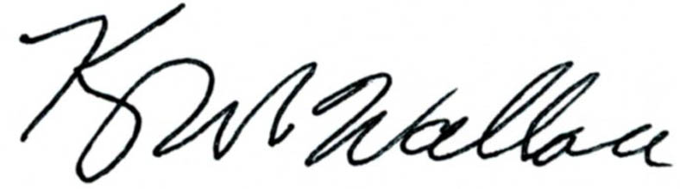
______________________________________ Chr.
Representative Kevin Wallace

YEAS: 27

Baker, Bennett, Echols, Fetgatter, Ford, Goodwin, Hilbert, Kannady, Lawson, Lepak, Martinez, McEntire, Meredith, Munson, Newton, Nichols, O'Donnell, Ortega, Osburn, Pfeiffer, Taylor, Virgin, Walke, Wallace, West (J), West (K), Worthen

NAYS: 0

CONSTITUTIONAL PRIVILEGE: 0

SB1057,1220,F,JOINT
OKLAHOMA HOUSE OF REPRESENTATIVES
COMMITTEE REPORT

JOINT COMMITTEE ON APPROPRIATIONS AND BUDGET COMMITTEE

SB1057

By: | Wallace et al of the House  Thompson et al of the Senate
Title: | Appropriation; making an appropriation to the Department of Mental Health and Substance Abuse Services. Emergency.
Coauthored By:
Recommendation: | DO PASS AS AMENDED BY CS

Amendments:

1. Committee Substitute Attached

______________________________________ Chr.
Representative Kevin Wallace

YEAS: 27

Baker, Bennett, Echols, Fetgatter, Ford, Goodwin, Hilbert, Kannady, Lawson, Lepak, Martinez, McEntire, Meredith, Munson, Newton, Nichols, O'Donnell, Ortega, Osburn, Pfeiffer, Taylor, Virgin, Walke, Wallace, West (J), West (K), Worthen

NAYS: 0

CONSTITUTIONAL PRIVILEGE: 0
STATE OF OKLAHOMA

1st Session of the 57th Legislature (2019)

COMMITTEE SUBSTITUTE
FOR
SENATE BILL NO. 1057 By: Thompson and Rader of the Senate

and

Wallace and Hilbert of the House

COMMITTEE SUBSTITUTE

An Act relating to the Department of Human Services; creating a revolving fund; providing that the fund shall not be subject to fiscal year limitations; describing sources of funding; directing the Director of the Department of Human Services to provide a monthly report to the Senate Appropriations Chair and the House Appropriations and Budget Chair; stating contents of the report; providing that all monies accruing to the credit of the fund are appropriated and may be budgeted and expended by the Department; stating allowable uses for the fund; requiring certain procedures for expenditures from the fund; providing for codification; and declaring an emergency.

BE IT ENACTED BY THE PEOPLE OF THE STATE OF OKLAHOMA:
SECTION 1. NEW LAW A new section of law to be codified in the Oklahoma Statutes as Section 229 of Title 56, unless there is created a duplication in numbering, reads as follows:
There is hereby created in the State Treasury a revolving fund for the Department of Human Services to be designated the "OK Benefits Revolving Fund". The fund shall be a continuing fund, not subject to fiscal year limitations, and shall consist of all monies designated to the fund by law. The Director of the Department of Human Services shall, at the end of each month, provide a current balance and statement of encumbrances of the fund to the Chair of the Senate Appropriations Committee and the Chair of the House of Representatives Committee on Appropriations and Budget. All monies accruing to the credit of the fund are hereby appropriated and may be budgeted and expended by the Department of Human Services for the sole purpose of the acquisition, operation, maintenance, repair and replacement of the OK Benefits system at the Department of Human Services. Expenditures from the fund shall be made upon warrants issued by the State Treasurer against claims filed as prescribed by law with the Director of the Office of Management and Enterprise Services for approval and payment.
SECTION 2. It being immediately necessary for the preservation of the public peace, health or safety, an emergency is hereby declared to exist, by reason whereof this act shall take effect and be in full force from and after its passage and approval.

57-1-2293 WR 7/30/2026 8:24:19 AM

