O K L A H O M A S T A T E S E N A T E
JOINT

COMMITTEE REPORT

May 20, 2019

JOINT COMMITTEE ON APPROPRIATIONS AND BUDGET

SB 1056

By: Thompson and Rader of the Senate and Wallace et al of the House

Title: Appropriations; making an appropriation to the Department of Human Services. Effective date. Emergency.

Recommendation: DO PASS AS AMENDED

Aye: Daniels, Dossett, Dugger, Floyd, Hall, Ikley-Freeman, Jech, Kidd, Matthews, Montgomery, Pemberton, Pugh, Rosino, Scott, Shaw, Simpson, Stanislawski, Rader, Thompson

Nay:

Constitutional Privilege:

Senator Roger Thompson, Chair

Committee Substitute, motion by Senator THOMPSON - Adopted (Request No: 2299)

SB1056,1220,F,JOINT
OKLAHOMA HOUSE OF REPRESENTATIVES
COMMITTEE REPORT

JOINT COMMITTEE ON APPROPRIATIONS AND BUDGET COMMITTEE

SB1056

By: | Wallace et al of the House  Thompson et al of the Senate
Title: | Appropriations; making an appropriation to the Department of Human Services. Effective date. Emergency.
Coauthored By:
Recommendation: | DO PASS AS AMENDED BY CS

Amendments:

1. Committee Substitute Attached

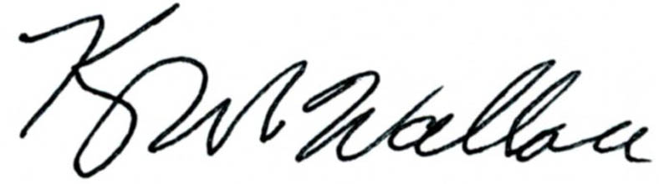
______________________________________ Chr.
Representative Kevin Wallace

YEAS: 27

Baker, Bennett, Echols, Fetgatter, Ford, Goodwin, Hilbert, Kannady, Lawson, Lepak, Martinez, McEntire, Meredith, Munson, Newton, Nichols, O'Donnell, Ortega, Osburn, Pfeiffer, Taylor, Virgin, Walke, Wallace, West (J), West (K), Worthen

NAYS: 0

CONSTITUTIONAL PRIVILEGE: 0
STATE OF OKLAHOMA

1st Session of the 57th Legislature (2019)

COMMITTEE SUBSTITUTE
FOR
SENATE BILL NO. 1056 By: Thompson and Rader of the Senate

and

Wallace and Hilbert of the House

COMMITTEE SUBSTITUTE

An Act relating to the Department of Human Services; creating a revolving fund; providing that the fund shall not be subject to fiscal year limitations; describing sources of funding; directing the Director of the Department of Human Services to provide a monthly report to the Senate Appropriations Chair and the House Appropriations and Budget Chair; stating contents of the report; providing that all monies accruing to the credit of the fund are appropriated and shall be budgeted and expended by the Departments only at the direction of the Legislature; stating allowable uses for the fund; requiring certain procedures for expenditures from the fund; providing for codification; and declaring an emergency.

BE IT ENACTED BY THE PEOPLE OF THE STATE OF OKLAHOMA:
SECTION 1. NEW LAW A new section of law to be codified in the Oklahoma Statutes as Section 229.1 of Title 56, unless there is created a duplication in numbering, reads as follows:
There is hereby created in the State Treasury a revolving fund for the Department of Human Services to be designated the "Department of Human Services Infrastructure Revolving Fund". The fund shall be a continuing fund, not subject to fiscal year limitations, and shall consist of all monies designated to the fund by law. The Director of the Department of Human Services shall, at the end of each month, provide a current balance and statement of encumbrances of the fund to the Chair of the Appropriations Committee of the Senate and the Chair of the Committee on Appropriations and Budget of the House of Representatives. All monies accruing to the credit of the fund are hereby appropriated and shall only be budgeted and expended at the direction of the Oklahoma Legislature. Expenditures from the fund shall be made upon warrants issued by the State Treasurer against claims filed as prescribed by law with the Director of the Office of Management and Enterprise Services for approval and payment.
SECTION 2. It being immediately necessary for the preservation of the public peace, health or safety, an emergency is hereby declared to exist, by reason whereof this act shall take effect and be in full force from and after its passage and approval.

57-1-2299 WR 7/30/2026 9:16:11 AM

