O K L A H O M A S T A T E S E N A T E
JOINT

COMMITTEE REPORT

May 16, 2019

JOINT COMMITTEE ON APPROPRIATIONS AND BUDGET

SB 1045

By: Thompson and Rader of the Senate and Wallace and Hilbert of the House

Title: Appropriations; making an appropriation to the Department of Corrections. Effective date. Emergency.

Recommendation: DO PASS AS AMENDED

Aye: Bice, Brooks, Daniels, Dossett, Dugger, Floyd, Hall, Ikley-Freeman, Jech, Kidd, Matthews, Montgomery, Pemberton, Pugh, Rosino, Scott, Shaw, Simpson, Stanislawski, Rader, Thompson

Nay:

Constitutional Privilege:

Senator Roger Thompson, Chair

Committee Substitute, motion by Senator THOMPSON - Adopted (Request No: 2313)

SB1045,1220,F,JOINT
OKLAHOMA HOUSE OF REPRESENTATIVES
COMMITTEE REPORT

JOINT COMMITTEE ON APPROPRIATIONS AND BUDGET COMMITTEE

SB1045

By: | Wallace et al of the House  Thompson et al of the Senate
Title: | Appropriations; making an appropriation to the Department of Corrections. Effective date. Emergency.
Coauthored By:
Recommendation: | DO PASS AS AMENDED BY CS

Amendments:

1. Committee Substitute Attached

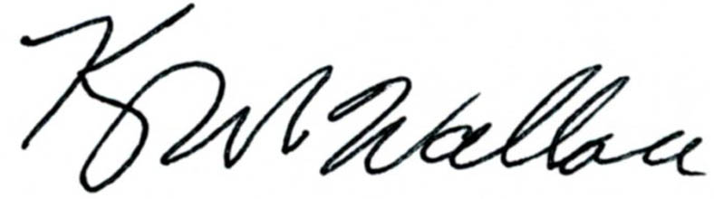
______________________________________ Chr.
Representative Kevin Wallace

YEAS: 25

Bennett, Echols, Fetgatter, Ford, Hilbert, Kannady, Lawson, Lepak, McEntire, Meredith, Munson, Nichols, O'Donnell, Ortega, Osburn, Pfeiffer, Roberts (D), Sanders, Taylor, Virgin, Walke, Wallace, West (J), West (K), Worthen

NAYS: 0

CONSTITUTIONAL PRIVILEGE: 0
STATE OF OKLAHOMA

1st Session of the 57th Legislature (2019)

COMMITTEE SUBSTITUTE
FOR
SENATE BILL NO. 1045 By: Thompson and Rader of the Senate

and

Wallace and Hilbert of the House

COMMITTEE SUBSTITUTE

An Act relating to prisons and reformatories; granting wage increase to personnel of Department of Corrections in certain job classifications; providing limitations; providing for codification; providing an effective date; and declaring an emergency.

BE IT ENACTED BY THE PEOPLE OF THE STATE OF OKLAHOMA:
SECTION 1. NEW LAW A new section of law to be codified in the Oklahoma Statutes as Section 528.7 of Title 57, unless there is created a duplication in numbering, reads as follows:
Effective July 1, 2019, all personnel of the Department of Corrections in the following job classifications who were employed by the state on the last working day of June 2019 shall be awarded an increase of Two Dollars ($2.00) per hour over their current hourly wage, or an equivalent amount if not receiving an hourly wage:
1. Chief of Security;
2. Construction/Maintenance Administrator;
3. Construction/Maintenance Technician;
4. Correctional Case Manager;
5. Correctional Chief of Security;
6. Correctional Records Officer;
7. Correctional Security Manager;
8. Correctional Security Officer;
9. Correctional Unit Assistant;
10. Customer Service Representative;
11. Food Service Manager;
12. Food Service Specialist;
13. Linen and Clothing Specialist;
14. Materiel Management Officer;
15. Materiel Management Specialist;
16. Unit Manager (DOC);
17. Advanced Practice Nurse;
18. Clinical Coordinator;
19. Correctional Health Service Administrator I;
20. Correctional Health Service Administrator II;
21. Correctional Health Service Administrator III;
22. Correctional Health Service Administrator IV;
23. Dental Care Assistant;
24. Dental Hygienist;
25. Dentist;
26. Health Information Technician;
27. Laboratory Technician;
28. Lead Psychiatrist;
29. Lead Staff Physician II;
30. Licensed Clinical Social Worker;
31. Licensed Practical Nurse;
32. Nursing Manager;
33. Optometrist;
34. Patient Care Assistant;
35. Psychiatrist;
36. Psychological Clinician;
37. Psychologist;
38. Regional Supervising Physician;
39. Registered Nurse;
40. Social Services Specialist; and
41. Staff Physician.
SECTION 2. This act shall become effective July 1, 2019.
SECTION 3. It being immediately necessary for the preservation of the public peace, health or safety, an emergency is hereby

declared to exist, by reason whereof this act shall take effect and be in full force from and after its passage and approval.

57-1-2313 CD 7/30/2026 11:09:46 AM

