HB2769,1220,F,JOINT
OKLAHOMA HOUSE OF REPRESENTATIVES
COMMITTEE REPORT

5/16/2019 6:52:44 PM

JOINT COMMITTEE ON APPROPRIATIONS AND BUDGET COMMITTEE

HB2769

By: | Wallace et al of the House  Thompson et al of the Senate
Title: | Appropriations and budget; Budget Implementation Act of 2019; effective date.
Coauthored By: | Add as coauthor Representative Hasenbeck
Recommendation: | DO PASS AS AMENDED BY CS

Amendments:

1. Committee Substitute Attached

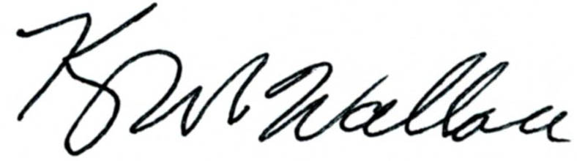
______________________________________ Chr.
Representative Kevin Wallace

YEAS: 20

Echols, Fetgatter, Ford, Hilbert, Kannady, Lawson, Lepak, Martinez, McEntire, O'Donnell, Ortega, Osburn, Pfeiffer, Roberts (D), Sanders, Taylor, Wallace, West (J), West (K), Worthen

NAYS: 6

Bennett, Meredith, Munson, Nichols, Virgin, Walke

CONSTITUTIONAL PRIVILEGE: 0
O K L A H O M A S T A T E S E N A T E
JOINT

COMMITTEE REPORT

May 16, 2019

JOINT COMMITTEE ON APPROPRIATIONS AND BUDGET

HB 2769

By: Wallace of the House and Thompson and Rader of the Senate

Title: Appropriations and budget; Budget Implementation Act of 2019; effective date.

Recommendation: DO PASS AS AMENDED

Aye: Bice, Daniels, Dugger, Hall, Jech, Kidd, Montgomery, Pemberton, Pugh, Rosino, Scott, Shaw, Simpson, Stanislawski, Rader, Thompson

Nay: Brooks, Dossett, Floyd, Ikley-Freeman, Matthews

Constitutional Privilege:

Senator Roger Thompson, Chair

Committee Substitute, motion by Senator THOMPSON - Adopted (Request No: 8917)

STATE OF OKLAHOMA

1st Session of the 57th Legislature (2019)

COMMITTEE SUBSTITUTE
FOR
HOUSE BILL NO. 2769 By: Wallace and Hilbert of the House

and

Thompson and Rader of the Senate

COMMITTEE SUBSTITUTE

An Act relating to public finance; repealing 62 O.S. 2011, Section 34.86, which relates to funding of common education by certain deadline; and providing an effective date.

BE IT ENACTED BY THE PEOPLE OF THE STATE OF OKLAHOMA:
SECTION 1. REPEALER 62 O.S. 2011, Section 34.86, is hereby repealed.
SECTION 2. This act shall become effective November 1, 2019.

57-1-8973 JM 05/16/19

