HB2767,1220,F,JOINT
OKLAHOMA HOUSE OF REPRESENTATIVES
COMMITTEE REPORT

5/16/2019 6:42:11 PM

JOINT COMMITTEE ON APPROPRIATIONS AND BUDGET COMMITTEE

HB2767

By: | Wallace et al of the House  Thompson et al of the Senate
Title: | Appropriations and budget; Budget Implementation Act of 2019; effective date.
Coauthored By:
Recommendation: | DO PASS AS AMENDED BY CS

Amendments:

1. Committee Substitute Attached

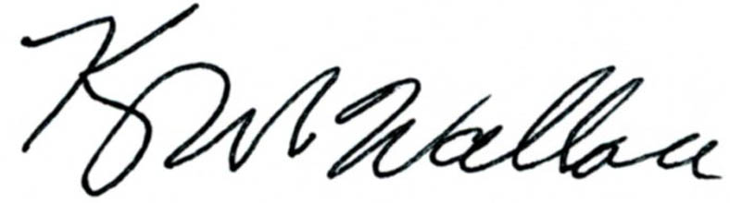
______________________________________ Chr.
Representative Kevin Wallace

YEAS: 25

Bennett, Echols, Fetgatter, Ford, Goodwin, Hilbert, Lawson, Lepak, McEntire, Meredith, Munson, Nichols, O'Donnell, Ortega, Osburn, Pfeiffer, Roberts (D), Sanders, Taylor, Virgin, Walke, Wallace, West (J), West (K), Worthen

NAYS: 0

CONSTITUTIONAL PRIVILEGE: 0
O K L A H O M A S T A T E S E N A T E
JOINT

COMMITTEE REPORT

May 16, 2019

JOINT COMMITTEE ON APPROPRIATIONS AND BUDGET

HB 2767

By: Wallace of the House and Thompson and Rader of the Senate

Title: Appropriations and budget; Budget Implementation Act of 2019; effective date.

Recommendation: DO PASS AS AMENDED

Aye: Bice, Brooks, Daniels, Dossett, Dugger, Floyd, Hall, Ikley-Freeman, Jech, Kidd, Matthews, Montgomery, Pemberton, Pugh, Rosino, Scott, Shaw, Simpson, Stanislawski, Rader, Thompson

Nay:

Constitutional Privilege:

Senator Roger Thompson, Chair

Committee Substitute, motion by Senator THOMPSON - Adopted (Request No: 8624)

STATE OF OKLAHOMA

1st Session of the 57th Legislature (2019)

COMMITTEE SUBSTITUTE
FOR
HOUSE BILL NO. 2767 By: Wallace and Hilbert of the House

and

Thompson and Rader of the Senate

COMMITTEE SUBSTITUTE

An Act relating to the Rate Preservation Fund; creating the Rate Preservation Fund; designating the nature of the fund; declaring fund monies appropriated; providing and limiting purpose of expenditure; requiring certain expenditure and budgetary procedures; authorizing certain transfers; providing for codification; and declaring an emergency.

BE IT ENACTED BY THE PEOPLE OF THE STATE OF OKLAHOMA:
SECTION 1. NEW LAW A new section of law to be codified in the Oklahoma Statutes as Section 5020A of Title 63, unless there is created a duplication in numbering, reads as follows:
There is hereby created in the State Treasury a fund for the Oklahoma Health Care Authority to be designated the "Rate Preservation Fund". The fund shall be a continuing fund, not subject to fiscal year limitations, and shall consist of monies designated to the fund by law. All monies accruing to the credit of the fund are hereby appropriated and may be budgeted and expended by the Authority for the sole purpose of maintaining reimbursement rates to providers when decreases in the state's Federal Medical Assistance Percentage (FMAP) rate would otherwise result in implementation of reimbursement rate decreases by the Authority. Expenditures from the fund shall be made upon warrants issued by the State Treasurer against claims filed as prescribed by law with the Director of the Office of Management and Enterprise Services for approval and payment. The Administrator of the Authority may request the Director of the Office of Management and Enterprise Services to transfer monies between the Rate Preservation Fund and any other fund of the Authority as needed for the expenditure of funds.
SECTION 2. It being immediately necessary for the preservation of the public peace, health or safety, an emergency is hereby declared to exist, by reason whereof this act shall take effect and be in full force from and after its passage and approval.

57-1-8969 JM 05/16/19

