HB2758,1220,F,JOINT
OKLAHOMA HOUSE OF REPRESENTATIVES
COMMITTEE REPORT

5/20/2019 5:37:23 PM

JOINT COMMITTEE ON APPROPRIATIONS AND BUDGET COMMITTEE

HB2758

By: | Wallace et al of the House  Thompson et al of the Senate
Title: | Appropriations and budget; Budget Implementation Act of 2019; effective date.
Coauthored By:
Recommendation: | DO PASS AS AMENDED BY CS

Amendments:

1. Committee Substitute Attached

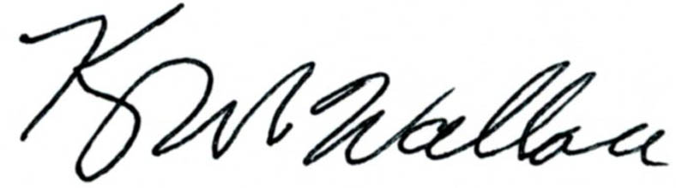
______________________________________ Chr.
Representative Kevin Wallace

YEAS: 28

Baker, Bennett, Echols, Fetgatter, Ford, Goodwin, Hilbert, Kannady, Lawson, Lepak, Martinez, McEntire, Meredith, Munson, Newton, Nichols, O'Donnell, Ortega, Osburn, Pfeiffer, Sanders, Taylor, Virgin, Walke, Wallace, West (J), West (K), Worthen

NAYS: 0

CONSTITUTIONAL PRIVILEGE: 0
O K L A H O M A S T A T E S E N A T E
JOINT

COMMITTEE REPORT

May 20, 2019

JOINT COMMITTEE ON APPROPRIATIONS AND BUDGET

HB 2758

By: Wallace of the House and Thompson and Rader of the Senate

Title: Appropriations and budget; Budget Implementation Act of 2019; effective date.

Recommendation: DO PASS AS AMENDED

Aye: Daniels, Dossett, Dugger, Floyd, Hall, Ikley-Freeman, Jech, Kidd, Matthews, Montgomery, Pemberton, Pugh, Rosino, Scott, Shaw, Simpson, Stanislawski, Rader, Thompson

Nay:

Constitutional Privilege:

Senator Roger Thompson, Chair

Committee Substitute, motion by Senator THOMPSON - Adopted (Request No: 8979)

STATE OF OKLAHOMA

1st Session of the 57th Legislature (2019)

COMMITTEE SUBSTITUTE
FOR
HOUSE BILL NO. 2758 By: Wallace and Hilbert of the House

and

Thompson and Rader of the Senate

COMMITTEE SUBSTITUTE

An Act relating to the Board of Medicolegal Investigations; providing legislative intent related to certain construction; providing legislative intent related to utilization of certain resources by the Board of Medicolegal Investigations and the Oklahoma State University Center for Health Sciences; and providing for noncodification.

BE IT ENACTED BY THE PEOPLE OF THE STATE OF OKLAHOMA:
SECTION 1. NEW LAW A new section of law not to be codified in the Oklahoma Statutes reads as follows:
A. It is the intent of the Legislature for the Board of Medicolegal Investigations to partner with the Oklahoma State University Center for Health Sciences (OSU-CHS) for the purpose of constructing a building that includes adequate space for the Tulsa location for the Board of Medicolegal Investigations, as well as space for OSU-CHS as agreed to between OSU-CHS and the Board of Medicolegal Investigations.
B. It is the intent of the Legislature for:
1. The Board of Medicolegal Investigations to utilize Five Million Five Hundred Thousand Dollars ($5,500,000.00) from the funds appropriated to the Board of Medicolegal Investigations in Enrolled House Bill No. 2765 of the 1st Session of the 57th Oklahoma Legislature, toward the furtherance of the provisions of subsection A of this section;
2. The Board of Medicolegal Investigations to utilize Four Million Five Hundred Thousand Dollars ($4,500,000.00) from existing agency resources toward the furtherance of the provisions of subsection A of this section; and
3. The Oklahoma State University Center for Health Sciences (OSU-CHS) to utilize Twenty Million Dollars ($20,000,000.00) from the funds received by OSU-CHS pursuant to Dean's GME program transition payments, toward the furtherance of the provisions of subsection A of this section.

57-1-8993 JM 05/20/19

