HB2757,1220,F,JOINT
OKLAHOMA HOUSE OF REPRESENTATIVES
COMMITTEE REPORT

5/17/2019 4:41:49 PM

JOINT COMMITTEE ON APPROPRIATIONS AND BUDGET COMMITTEE

HB2757

By: | Wallace et al of the House  Thompson et al of the Senate
Title: | Appropriations and budget; Budget Implementation Act of 2019; effective date.
Coauthored By:
Recommendation: | DO PASS AS AMENDED BY CS

Amendments:

1. Committee Substitute Attached

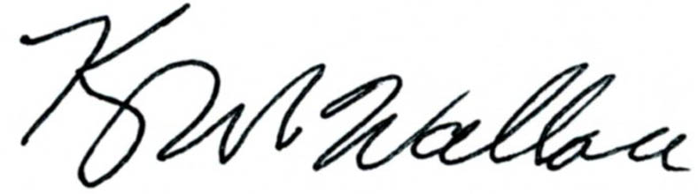
______________________________________ Chr.
Representative Kevin Wallace

YEAS: 23

Bennett, Fetgatter, Ford, Goodwin, Hilbert, Lawson, Lepak, Martinez, McEntire, Meredith, Munson, Nichols, Ortega, Pfeiffer, Roberts (D), Sanders, Taylor, Virgin, Walke, Wallace, West (J), West (K), Worthen

NAYS: 0

CONSTITUTIONAL PRIVILEGE: 1
O K L A H O M A S T A T E S E N A T E
JOINT

COMMITTEE REPORT

May 17, 2019

JOINT COMMITTEE ON APPROPRIATIONS AND BUDGET

HB 2757

By: Wallace of the House and Thompson and Rader of the Senate

Title: Appropriations and budget; Budget Implementation Act of 2019; effective date.

Recommendation: DO PASS AS AMENDED

Aye: Bice, Brooks, Daniels, Dugger, Hall, Ikley-Freeman, Jech, Kidd, Montgomery, Pemberton, Pugh, Rosino, Scott, Simpson, Stanislawski, Rader, Thompson

Nay:

Constitutional Privilege:

Senator Roger Thompson, Chair

Committee Substitute, motion by Senator THOMPSON - Adopted (Request No: 8982)

STATE OF OKLAHOMA

1st Session of the 57th Legislature (2019)

COMMITTEE SUBSTITUTE
FOR
HOUSE BILL NO. 2757 By: Wallace and Hilbert of the House

and

Thompson and Rader of the Senate

COMMITTEE SUBSTITUTE

An Act relating to the Oklahoma Department of Corrections; requiring transfer of certain funds; providing an effective date; and declaring an emergency.

BE IT ENACTED BY THE PEOPLE OF THE STATE OF OKLAHOMA:
SECTION 1. From the funds appropriated to the Oklahoma Department of Corrections in Section 94 of Enrolled House Bill No. 2765 of the 1st Session of the 57th Oklahoma Legislature, the sum of One Million Dollars ($1,000,000.00) shall be transferred to the Department of Corrections Offender Transport Revolving Fund created in Section 2 of Enrolled House Bill No. 1374 of the 1st Session of the 57th Oklahoma Legislature.
SECTION 2. This act shall become effective July 1, 2019.
SECTION 3. It being immediately necessary for the preservation of the public peace, health or safety, an emergency is hereby declared to exist, by reason whereof this act shall take effect and be in full force from and after its passage and approval.

57-1-8985 JM 5/17/19

