HB2755,1220,F,JOINT
OKLAHOMA HOUSE OF REPRESENTATIVES
COMMITTEE REPORT

5/20/2019 5:42:33 PM

JOINT COMMITTEE ON APPROPRIATIONS AND BUDGET COMMITTEE

HB2755

By: | Wallace et al of the House  Thompson et al of the Senate
Title: | State government; Government Reform Act of 2019; effective date.
Coauthored By:
Recommendation: | DO PASS AS AMENDED BY CS

Amendments:

1. Committee Substitute Attached

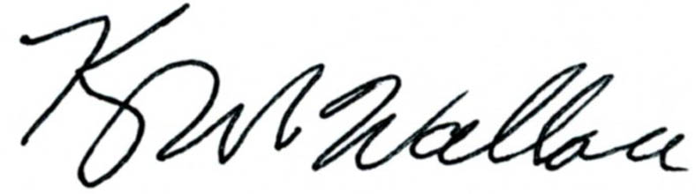
______________________________________ Chr.
Representative Kevin Wallace

YEAS: 28

Baker, Bennett, Echols, Fetgatter, Ford, Goodwin, Hilbert, Kannady, Lawson, Lepak, Martinez, McEntire, Meredith, Munson, Newton, Nichols, O'Donnell, Ortega, Osburn, Pfeiffer, Sanders, Taylor, Virgin, Walke, Wallace, West (J), West (K), Worthen

NAYS: 0

CONSTITUTIONAL PRIVILEGE: 0
O K L A H O M A S T A T E S E N A T E
JOINT

COMMITTEE REPORT

May 20, 2019

JOINT COMMITTEE ON APPROPRIATIONS AND BUDGET

HB 2755

By: Wallace of the House and Thompson and Rader of the Senate

Title: State government; Government Reform Act of 2019; effective date.

Recommendation: DO PASS AS AMENDED

Aye: Daniels, Dugger, Hall, Jech, Kidd, Montgomery, Pemberton, Pugh, Rosino, Scott, Shaw, Simpson, Stanislawski, Rader, Thompson

Nay: Dossett, Floyd, Ikley-Freeman, Matthews

Constitutional Privilege:

Senator Roger Thompson, Chair

Committee Substitute, motion by Senator THOMPSON - Adopted (Request No: 8992)

STATE OF OKLAHOMA

1st Session of the 57th Legislature (2019)

COMMITTEE SUBSTITUTE
FOR
HOUSE BILL NO. 2755 By: Wallace and Hilbert of the House

and

Thompson and Rader of the Senate

COMMITTEE SUBSTITUTE

An Act relating to the Office of Management and Enterprise Services; providing for reappropriation and redesignation of certain funds in certain amount for a certain purpose; authorizing certain expenditures of certain funds; providing amounts; providing purposes; and declaring an emergency.

BE IT ENACTED BY THE PEOPLE OF THE STATE OF OKLAHOMA:
SECTION 1. REAPPROPRIATION AND REDESIGNATION The amount of Two Million Six Hundred Thousand Dollars ($2,600,000.00) of the original appropriation of Five Million Six Hundred Thousand Dollars ($5,600,000.00), appropriated to the Office of Management and Enterprise Services by Section 132, Chapter 146, O.S.L. 2018, from any monies not otherwise appropriated from the Special Cash Fund of the State Treasury to reconcile costs associated with the funding of state pension systems, is hereby reappropriated and redesignated to the Office of Management and Enterprise Services to perform duties imposed upon the Office by law. If, on the date this act is approved, any of the amount originally appropriated, as adjusted by expenditures, encumbrances and transfers, results in an unencumbered balance less than the reappropriated and redesignated amount, that reappropriated and redesignated amount is reduced to the unencumbered amount.
SECTION 2. Notwithstanding any other provision of law, the Office of Management and Enterprise Services is hereby authorized to expend during the fiscal year ending June 30, 2019, from the Postal Service Revolving Fund (Fund 231), the sum of One Hundred Fifty Thousand Dollars ($150,000.00) or so much thereof as may be necessary to perform the duties imposed upon the Office of Management and Enterprise Services by law.
SECTION 3. Notwithstanding any other provision of law, the Office of Management and Enterprise Services is hereby authorized to expend during the fiscal year ending June 30, 2019, from the Registration of State Vendors Revolving Fund (Fund 270), the sum of Fifty Thousand Dollars ($50,000.00) or so much thereof as may be necessary to perform the duties imposed upon the Office of Management and Enterprise Services by law.
SECTION 4. Notwithstanding any other provision of law, the Office of Management and Enterprise Services is hereby authorized to expend during the fiscal year ending June 30, 2019, from the Vendor Fees and Rebates Revolving Fund (Fund 271), the sum of One Million Two Hundred Fifty Thousand Dollars ($1,250,000.00) or so much thereof as may be necessary to perform the duties imposed upon the Office of Management and Enterprise Services by law.
SECTION 5. It being immediately necessary for the preservation of the public peace, health or safety, an emergency is hereby declared to exist, by reason whereof this act shall take effect and be in full force from and after its passage and approval.

57-1-8994 JM 05/20/19

