HB2746,1220,F,JOINT
OKLAHOMA HOUSE OF REPRESENTATIVES
COMMITTEE REPORT

5/16/2019 6:23:55 PM

JOINT COMMITTEE ON APPROPRIATIONS AND BUDGET COMMITTEE

HB2746

By: | Wallace et al of the House  Thompson et al of the Senate
Title: | Appropriations and budget; Budget Implementation Act of 2019; effective date.
Coauthored By:
Recommendation: | DO PASS AS AMENDED BY CS

Amendments:

1. Committee Substitute Attached

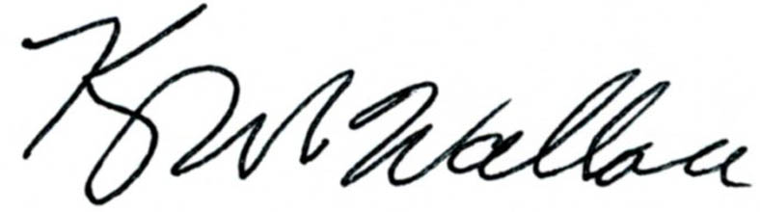
______________________________________ Chr.
Representative Kevin Wallace

YEAS: 20

Echols, Fetgatter, Ford, Hilbert, Kannady, Lawson, Lepak, Martinez, McEntire, Nichols, O'Donnell, Ortega, Osburn, Pfeiffer, Sanders, Taylor, Wallace, West (J), West (K), Worthen

NAYS: 6

Bennett, Goodwin, Meredith, Munson, Virgin, Walke

CONSTITUTIONAL PRIVILEGE: 0
O K L A H O M A S T A T E S E N A T E
JOINT

COMMITTEE REPORT

May 16, 2019

JOINT COMMITTEE ON APPROPRIATIONS AND BUDGET

HB 2746

By: Wallace of the House and Thompson and Rader of the Senate

Title: Appropriations and budget; Budget Implementation Act of 2019; effective date.

Recommendation: DO PASS AS AMENDED

Aye: Bice, Brooks, Daniels, Dossett, Dugger, Floyd, Hall, Ikley-Freeman, Jech, Kidd, Matthews, Montgomery, Pemberton, Pugh, Rosino, Scott, Shaw, Simpson, Stanislawski, Rader, Thompson

Nay:

Constitutional Privilege:

Senator Roger Thompson, Chair

Committee Substitute, motion by Senator THOMPSON - Adopted (Request No: 8964)

STATE OF OKLAHOMA

1st Session of the 57th Legislature (2019)

COMMITTEE SUBSTITUTE
FOR
HOUSE BILL NO. 2746 By: Wallace and Hilbert of the House

and

Thompson and Rader of the Senate

COMMITTEE SUBSTITUTE

An Act relating to the Digital Transformation Program Revolving Fund; designating the nature of the fund; declaring fund monies appropriated; providing and limiting purpose of expenditure; requiring certain expenditure and budgetary procedures; requiring certain periodic reporting of certain information to certain individuals; providing for codification; and declaring an emergency.

BE IT ENACTED BY THE PEOPLE OF THE STATE OF OKLAHOMA:
SECTION 1. NEW LAW A new section of law to be codified in the Oklahoma Statutes as Section 36 of Title 62, unless there is created a duplication in numbering, reads as follows:
A. There is hereby created in the State Treasury a fund for the Office of Management and Enterprise Services to be designated the "Digital Transformation Program Revolving Fund". The fund shall be a continuing fund, not subject to fiscal year limitations, and shall consist of monies designated to the fund by law. All monies accruing to the credit of the fund are hereby appropriated and may be budgeted and expended by the Office of Management and Enterprise Services for the sole purpose of implementing digital transformation initiatives. Expenditures from the fund shall be made upon warrants issued by the State Treasurer against claims filed as prescribed by law with the Director of the Office of Management and Enterprise Services for approval and payment.
B. Monthly the Director of the Office of Management and Enterprise Services shall submit reports to the Speaker of the Oklahoma House of Representatives, the President Pro Tempore of the Oklahoma State Senate, the Chair of the Appropriations and Budget Committee of the Oklahoma House of Representatives and the Chair of the Appropriations Committee of the Oklahoma State Senate detailing:
1. Expenditures from the Digital Transformation Program Revolving Fund; and
2. Projects under consideration for future expenditures from the fund.
SECTION 2. It being immediately necessary for the preservation of the public peace, health or safety, an emergency is hereby
declared to exist, by reason whereof this act shall take effect and be in full force from and after its passage and approval.

57-1-8976 JM 05/16/19

