HB2745,1220,F,JOINT
OKLAHOMA HOUSE OF REPRESENTATIVES
COMMITTEE REPORT

5/16/2019 6:03:55 PM

JOINT COMMITTEE ON APPROPRIATIONS AND BUDGET COMMITTEE

HB2745

By: | Wallace et al of the House  Thompson et al of the Senate
Title: | State government; Government Reform Act of 2019; effective date.
Coauthored By:
Recommendation: | DO PASS AS AMENDED BY CS

Amendments:

1. Committee Substitute Attached

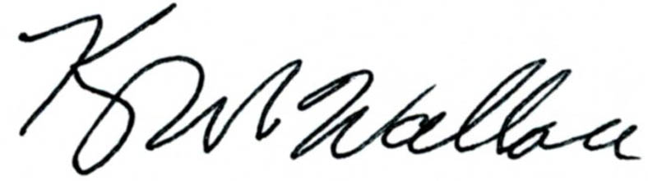
______________________________________ Chr.
Representative Kevin Wallace

YEAS: 21

Echols, Fetgatter, Ford, Hilbert, Kannady, Lawson, Lepak, Martinez, McEntire, O'Donnell, Ortega, Osburn, Pfeiffer, Roberts (D), Sanders, Taylor, Walke, Wallace, West (J), West (K), Worthen

NAYS: 6

Bennett, Goodwin, Meredith, Munson, Nichols, Virgin

CONSTITUTIONAL PRIVILEGE: 0
O K L A H O M A S T A T E S E N A T E
JOINT

COMMITTEE REPORT

May 16, 2019

JOINT COMMITTEE ON APPROPRIATIONS AND BUDGET

HB 2745

By: Wallace of the House and Thompson and Rader of the Senate

Title: State government; Government Reform Act of 2019; effective date.

Recommendation: DO PASS AS AMENDED

Aye: Bice, Brooks, Daniels, Dossett, Dugger, Hall, Ikley-Freeman, Jech, Kidd, Matthews, Montgomery, Pemberton, Pugh, Rosino, Scott, Shaw, Simpson, Stanislawski, Rader, Thompson

Nay: Floyd

Constitutional Privilege:

Senator Roger Thompson, Chair

Committee Substitute, motion by Senator THOMPSON - Adopted (Request No: 8850)

STATE OF OKLAHOMA

1st Session of the 57th Legislature (2019)

COMMITTEE SUBSTITUTE
FOR
HOUSE BILL NO. 2745 By: Wallace and Hilbert of the House

and

Thompson and Rader of the Senate

COMMITTEE SUBSTITUTE

An Act relating to state government; amending 74 O.S. 2011, Section 4258, as last amended by Section 1, Chapter 150, O.S.L. 2015 (74 O.S. Supp. 2018, Section 4258), which relates to the Ethics Commission Fund; limiting annual deposits to Fund; providing for deposit of collections in excess of limit; providing an effective date; and declaring an emergency.

BE IT ENACTED BY THE PEOPLE OF THE STATE OF OKLAHOMA:
SECTION 1. AMENDATORY 74 O.S. 2011, Section 4258, as last amended by Section 1, Chapter 150, O.S.L. 2015 (74 O.S. Supp. 2018, Section 4258), is amended to read as follows:
Section 4258. A. There is hereby created in the State Treasury a revolving fund for the Ethics Commission to be designated the "Ethics Commission Fund". The fund Ethics Commission Fund shall be a continuing fund, not subject to fiscal year limitations and shall consist of all the first One Hundred Fifty Thousand Dollars ($150,000.00) of fees received by the Commission each fiscal year. Fees collected each fiscal year in excess of One Hundred Fifty Thousand Dollars ($150,000.00) shall be placed to the credit of the General Revenue Fund.
B. All monies accruing to the credit of the fund Ethics Commission Fund are hereby appropriated and may be budgeted and expended by the Commission for any expenses incurred in the implementation of its duties as provided by law. Expenditures from the fund shall be made upon warrants issued by the State Treasurer against claims filed as prescribed by law with the Director of the Office of Management and Enterprise Services for approval and payment.
SECTION 2. This act shall become effective July 1, 2019.
SECTION 3. It being immediately necessary for the preservation of the public peace, health or safety, an emergency is hereby declared to exist, by reason whereof this act shall take effect and be in full force from and after its passage and approval.

57-1-8977 JM 05/16/19

