HB2738,1220,F,JOINT
OKLAHOMA HOUSE OF REPRESENTATIVES
COMMITTEE REPORT

2/20/2019 5:07:30 PM

JOINT COMMITTEE ON APPROPRIATIONS AND BUDGET COMMITTEE

HB2738

By: | Wallace et al of the House  Thompson et al of the Senate
Title: | Appropriations and budget; State Budget Implementation Act of 2019; effective date.
Coauthored By:
Recommendation: | DO PASS AS AMENDED BY CS

Amendments:

1. Committee Substitute Attached

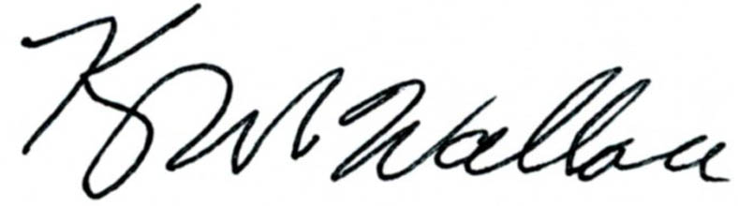
______________________________________ Chr.
Representative Kevin Wallace

YEAS: 27

Baker, Bennett, Fetgatter, Ford, Goodwin, Hilbert, Lawson, Lepak, Martinez, McBride, McEntire, Meredith, Munson, Newton, Nichols, Ortega, Osburn, Pfeiffer, Roberts (D), Russ, Taylor, Virgin, Walke, Wallace, West (J), West (K), Worthen

NAYS: 0

CONSTITUTIONAL PRIVILEGE: 0
O K L A H O M A S T A T E S E N A T E
JOINT

COMMITTEE REPORT

February 20, 2019

JOINT COMMITTEE ON APPROPRIATIONS AND BUDGET

HB 2738

By: Wallace of the House and Thompson and Rader of the Senate

Title: Appropriations and budget; State Budget Implementation Act of 2019; effective date.

Recommendation: DO PASS AS AMENDED

Aye: Brooks, Daniels, Dossett, Dugger, Floyd, Hall, Ikley-Freeman, Jech, Kidd, Matthews, Montgomery, Pemberton, Rosino, Scott, Shaw, Simpson, Stanislawski, Rader, Thompson

Nay:

Constitutional Privilege:

Senator Roger Thompson, Chair

Committee Substitute, motion by Senator THOMPSON - Adopted (Request No: 8052)

STATE OF OKLAHOMA

1st Session of the 57th Legislature (2019)

COMMITTEE SUBSTITUTE
FOR
HOUSE BILL NO. 2738 By: Wallace and Hilbert of the House

and

Thompson and Rader of the Senate

COMMITTEE SUBSTITUTE

An Act relating to soldiers and sailors; repealing 72 O.S. 2011, Section 241, as last amended by Section 1, Chapter 293, O.S.L. 2017 (72 O.S. Supp. 2018, Section 241), which relates to the State Accrediting Agency; and declaring an emergency.

BE IT ENACTED BY THE PEOPLE OF THE STATE OF OKLAHOMA:
SECTION 1. REPEALER 72 O.S. 2011, Section 241, as last amended by Section 1, Chapter 293, O.S.L. 2017 (72 O.S. Supp. 2018, Section 241), is hereby repealed.
SECTION 2. It being immediately necessary for the preservation of the public peace, health or safety, an emergency is hereby
declared to exist, by reason whereof this act shall take effect and be in full force from and after its passage and approval.

57-1-8123 JM 02/20/19

