HB2736,1220,F,JOINT
OKLAHOMA HOUSE OF REPRESENTATIVES
COMMITTEE REPORT

2/20/2019 5:06:41 PM

JOINT COMMITTEE ON APPROPRIATIONS AND BUDGET COMMITTEE

HB2736

By: | Wallace et al of the House  Thompson et al of the Senate
Title: | Appropriations and budget; creating the State Budget Implementation Act of 2019; effective date.
Coauthored By:
Recommendation: | DO PASS AS AMENDED BY CS

Amendments:

1. Committee Substitute Attached

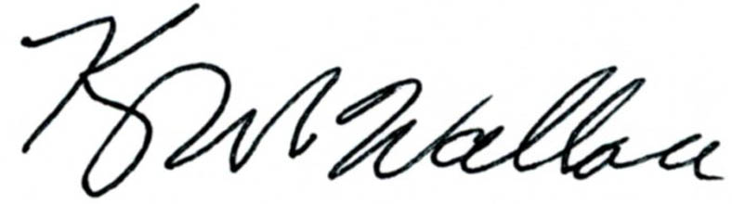
______________________________________ Chr.
Representative Kevin Wallace

YEAS: 27

Baker, Bennett, Fetgatter, Ford, Goodwin, Hilbert, Lawson, Lepak, Martinez, McBride, McEntire, Meredith, Munson, Newton, Nichols, Ortega, Osburn, Pfeiffer, Roberts (D), Russ, Taylor, Virgin, Walke, Wallace, West (J), West (K), Worthen

NAYS: 0

CONSTITUTIONAL PRIVILEGE: 0
O K L A H O M A S T A T E S E N A T E
JOINT

COMMITTEE REPORT

February 20, 2019

JOINT COMMITTEE ON APPROPRIATIONS AND BUDGET

HB 2736

By: Wallace of the House and Thompson and Rader of the Senate

Title: Appropriations and budget; creating the State Budget Implementation Act of 2019; effective date.

Recommendation: DO PASS AS AMENDED

Aye: Brooks, Daniels, Dossett, Dugger, Floyd, Hall, Ikley-Freeman, Jech, Kidd, Matthews, Montgomery, Rosino, Shaw, Simpson, Stanislawski, Rader, Thompson

Nay:

Constitutional Privilege:

Senator Roger Thompson, Chair

Committee Substitute, motion by Senator THOMPSON - Adopted (Request No: 15053)

STATE OF OKLAHOMA

1st Session of the 57th Legislature (2019)

COMMITTEE SUBSTITUTE
FOR
HOUSE BILL NO. 2736 By: Wallace and Hilbert of the House

and

Thompson and Rader of the Senate

COMMITTEE SUBSTITUTE

An Act relating to the State Department of Health; repealing Section 1, Chapter 3, 1st Extraordinary Session, O.S.L. 2017, which relates to certain mandated corrective action reports and recommendations for funding reduction; and declaring an emergency.

BE IT ENACTED BY THE PEOPLE OF THE STATE OF OKLAHOMA:
SECTION 1. REPEALER Section 1, Chapter 3, 1st Extraordinary Session, O.S.L. 2017, is hereby repealed.
SECTION 2. It being immediately necessary for the preservation of the public peace, health or safety, an emergency is hereby
declared to exist, by reason whereof this act shall take effect and be in full force from and after its passage and approval.

57-1-8121 JM 02/20/19

