HB2735,1220,F,JOINT
OKLAHOMA HOUSE OF REPRESENTATIVES
COMMITTEE REPORT

2/20/2019 5:06:10 PM

JOINT COMMITTEE ON APPROPRIATIONS AND BUDGET COMMITTEE

HB2735

By: | Wallace et al of the House  Thompson et al of the Senate
Title: | Appropriations and budget; creating State Budget Implementation Act of 2019; effective date.
Coauthored By:
Recommendation: | DO PASS AS AMENDED BY CS

Amendments:

1. Committee Substitute Attached

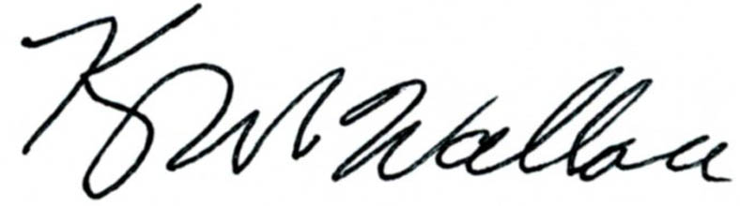
______________________________________ Chr.
Representative Kevin Wallace

YEAS: 27

Baker, Bennett, Fetgatter, Ford, Goodwin, Hilbert, Lawson, Lepak, Martinez, McBride, McEntire, Meredith, Munson, Newton, Nichols, Ortega, Osburn, Pfeiffer, Roberts (D), Russ, Taylor, Virgin, Walke, Wallace, West (J), West (K), Worthen

NAYS: 0

CONSTITUTIONAL PRIVILEGE: 0
O K L A H O M A S T A T E S E N A T E
JOINT

COMMITTEE REPORT

February 20, 2019

JOINT COMMITTEE ON APPROPRIATIONS AND BUDGET

HB 2735

By: Wallace of the House and Thompson and Rader of the Senate

Title: Appropriations and budget; creating State Budget Implementation Act of 2019; effective date.

Recommendation: DO PASS AS AMENDED

Aye: Brooks, Daniels, Dossett, Dugger, Floyd, Hall, Ikley-Freeman, Jech, Kidd, Matthews, Montgomery, Rosino, Shaw, Simpson, Rader, Thompson

Nay:

Constitutional Privilege:

Senator Roger Thompson, Chair

Committee Substitute, motion by Senator THOMPSON - Adopted (Request No: 15054)

STATE OF OKLAHOMA

1st Session of the 57th Legislature (2019)

COMMITTEE SUBSTITUTE
FOR
HOUSE BILL NO. 2735 By: Wallace and Hilbert of the House

and

Thompson and Rader of the Senate

COMMITTEE SUBSTITUTE

An Act relating to State Department of Health funding; amending Section 63, Chapter 146, O.S.L. 2018, which relates to the appropriation to the State Department of Health for Fiscal Year 2019; reducing amount of the appropriation; making appropriations to the Special Cash Fund of the State Treasury; identifying sources; stating amounts of the appropriations; stating purposes; and declaring an emergency.

BE IT ENACTED BY THE PEOPLE OF THE STATE OF OKLAHOMA:
SECTION 1. AMENDATORY Section 63, Chapter 146, O.S.L. 2018, is amended to read as follows:
Section 63. There is hereby appropriated to the State Department of Health from any monies not otherwise appropriated from the General Revenue Fund of the State Treasury for the fiscal year ending June 30, 2019, the sum of Fifty-four Million Eight Hundred Seventy-four Thousand Seven Hundred Dollars ($54,874,700.00) Fifty-one Million One Hundred Seventy-four Thousand Seven Hundred Dollars ($51,174,700.00) or so much thereof as may be necessary to perform the duties imposed upon the State Department of Health by law.
SECTION 2. An amount of Nine Million Three Hundred Fifty-seven Thousand Two Hundred Fifty-five Dollars ($9,357,255.00) from the amount of Thirty Million Dollars ($30,000,000.00) originally appropriated to the State Department of Health from the General Revenue Fund of the State Treasury for the fiscal year ending June 30, 2017, by Section 169, Chapter 2, 1st Extraordinary Session, O.S.L. 2017, is hereby appropriated to the Special Cash Fund of the State Treasury for availability of appropriation.
SECTION 3. An amount of Thirteen Million Nine Hundred Twenty-one Thousand Six Hundred Forty-four Dollars ($13,921,644.00) from the amount of Fifty-two Million Seven Hundred Thirty-five Thousand Eight Hundred Sixty-six Dollars ($52,735,866.00) originally appropriated to the State Department of Health from the General Revenue Fund of the State Treasury for the fiscal year ending June 30, 2018, by Section 73, Chapter 3, 2nd Extraordinary Session, O.S.L. 2018, is hereby appropriated to the Special Cash Fund of the State Treasury for availability of appropriation.
SECTION 4. There is hereby appropriated to the Special Cash Fund of the State Treasury from any monies not otherwise appropriated from the Public Health Special Fund (210) of the State Department of Health the sum of Three Million Twenty-one Thousand One Hundred One Dollars ($3,021,101.00) for availability of appropriation.
SECTION 5. It being immediately necessary for the preservation of the public peace, health or safety, an emergency is hereby declared to exist, by reason whereof this act shall take effect and be in full force from and after its passage and approval.

57-1-8120 JM 02/20/19

